# Brainstorm

**TIP**

You can select a sticky note and hit the pencil [switch to sketch] icon to start drawing!

#### Before you collaborate

A little bit of preparation goes a long way with this session. Here’s what you need to do to get going.

**10 minutes**

**1**

#### Define your problem statement

What problem are you trying to solve? Frame your problem as a How Might We statement. This will be the focus of your brainstorm.

**5 minutes**

**Shows cash fow**

**2**

#### Brainstorm

Write down any ideas that come to mind that address your problem statement.

**10 minutes**

**3**

#### Group ideas

Take turns sharing your ideas while clustering similar or related notes as you go. In the last 10 minutes, give each cluster a sentence-like label. If a cluster is bigger than six sticky notes, try and see if you and break it up into smaller sub-groups.

**20 minutes**

**4**

#### Prioritize

Your team should all be on the same page about what's important moving forward. Place your ideas on this grid to determine which ideas are important and which are feasible.

**20 minutes**

#### After you collaborate

You can export the mural as an image or pdf to share with members of your company who might find it helpful.

**Quick add-ons**

# & idea prioritization

**PROBLEM**

**How to help the user to get tracking of monthly spenses and send alerts about spending expenses**

Use this template in your own brainstorming sessions so your team can unleash their imagination and start shaping concepts even if you're not sitting in the same room.

1. **Team gathering**

Define who should participate in the session and send an invite. Share relevant information or pre-work ahead.

1. **Set the goal**

Think about the problem you'll be focusing on solving in the brainstorming session.

1. **Learn how to use the facilitation tools**

Use the Facilitation Superpowers to run a happy and productive session.

**Gokhulavaasan**

**To user to enter the spending**

**Limitations for budget**

**Add income and expenses**

**Gopinath**

## 

**Set smart budget to help you not over spend money in a choosen catagory**

**Create a additional steam of income**

**Get monthly report as pdf or excel sheet**

**TIP**

Add customizable tags to sticky notes to make it easier to find, browse, organize, and categorize important ideas as themes within your mural.

**Track your income and expenses**

**Edit income and expenses**

1. **Share the mural**

**Share a view link** to the mural with stakeholders to keep them in the loop about the outcomes of the session.

1. **Export the mural**

Export a copy of the mural as a PNG or PDF to attach to emails, include in slides, or save in your drive.

**Helps you to**

**stick on your budget and cut out impulse spending**

**Filter the expenses periodically**

**Keep accurate records**

**Add remainder and get notify**

**10 minutes** to prepare

**1 hour** to collaborate

**2-8 people** recommended

[**Open article**](https://support.mural.co/en/articles/2113740-facilitation-superpowers)

**Add income and expenses**

#### Key rules of brainstorming

To run an smooth and productive session

**Gunanithi**

**Navigate to dash board**

**Get monthly report**

**Hari**

**To remind user to enter the spendings**

**Generate Monthly report**

**Set Budget**

**Set budget**

**Overspending / underspending of money**

**No need for complicated Excel sheets**

**Generate monthly record**

**Show cash flow**

**Visualize the expense**

**Keep moving forward**

**Strategy blueprint**

Define the components of a new idea or strategy.

[**Open the template**](https://app.mural.co/template/e95f612a-f72a-4772-bc48-545aaa04e0c9/984865a6-0a96-4472-a48d-47639307b3ca)

**Customer experience journey map**

Stay in topic. Defer judgment.

**Add multiple stream of income**

**Edit user profile**

**Categorize the expenses**

Encourage wild ideas. Listen to others.

#### Importance

**Helps you to stick on your budget and cut out impulse spending**

If each of these

Understand customer needs, motivations, and

obstacles for an experience.

|  |  |  |  |  |  |  |
| --- | --- | --- | --- | --- | --- | --- |
|  | | | | | | |
|  | **Keep accurate records** |  | **Generate Monthly report** |  | **Add income and expenses** |  |
|  | **Filter the expenses periodically** |  | **Add multiple stream of income** |  | **Set budget** |
| **Set smart budget to help you not over spend money in a choosen catagory** |  | **To remind user to enter the spendings** | **Categorize your expenses** |  |  |
|  |  | **Add remainder and get notify** |  | **Helps you to stick on your budget and cut out impulse spending** |  |
|  | **Edit User Profle** |  |  |  |  |
| **Navigate to the dashboard** |  |  |  |  |  |

[**Open the template**](https://app.mural.co/template/b7114010-3a67-4d63-a51d-6f2cedc9633f/c1b465ab-57af-4624-8faf-ebb312edc0eb)

**Feedback System**

[**Share template feedback**](https://muralco.typeform.com/to/CiqaHVat?typeform-source=app.mural.co)

Go for volume. If possible, be visual.

### Alert

tasks could get

done without any difficulty or cost, which would have the most positive impact?

**Set remainder and get notifed**

**To remind user to enter the spendings**

#### Feasibility

Regardless of their importance, which tasks are more feasible than others? (Cost, time, effort, complexity, etc.)

**Strengths, weaknesses, opportunities & threats**

Identify strengths, weaknesses, opportunities, and threats (SWOT) to develop a plan.

|  |  |
| --- | --- |
|  |  |
|  |  |

[**Open the template**](https://app.mural.co/template/6a062671-89ee-4b76-9409-2603d8b098be/ca270343-1d54-4952-9d8c-fbc303ffd0f2)

[**Share template feedback**](https://muralco.typeform.com/to/CiqaHVat?typeform-source=app.mural.co)

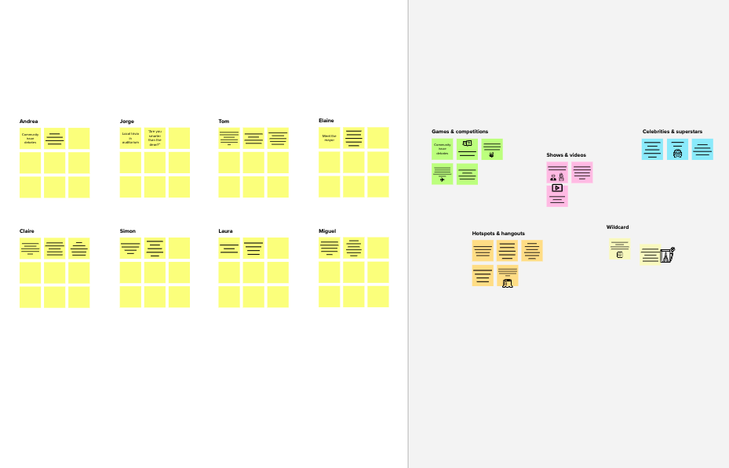

**Template**

**Need some inspiration?**

See a finished version of this template to kickstart your work.

[**Open example**](https://app.mural.co/template/e5a93b7b-49f2-48c9-afd7-a635d860eba6/93f1b98d-b2d2-4695-8e85-7e9c0d2fd9b9)